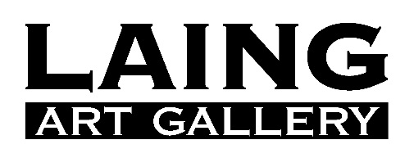

The Enchanted Interior

12 October 2019 - 22 February 2020
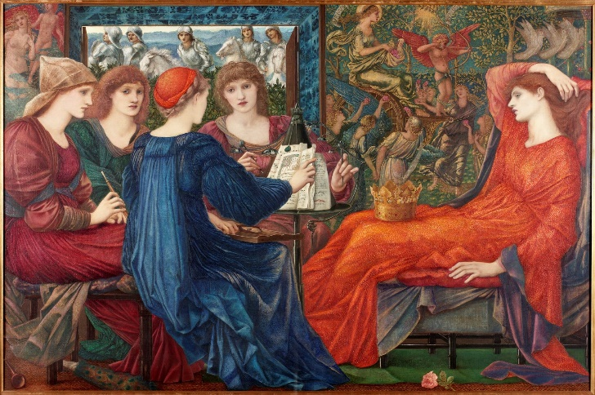
The Enchanted Interior will explore the sinister implications of a popular theme in 19th-century painting: the depiction of the interior as a ‘gilded cage’ in which women are pictured as ornamental objects.
Iconic Pre-Raphaelite and British Orientalist paintings by artists such as Edward Burne-Jones, William Holman Hunt and John Frederick Lewis will be shown alongside works by their female peers such as Emma Sandys and Evelyn De Morgan, who challenge and subvert the idealisation of women as captive damsels or passive beauties.
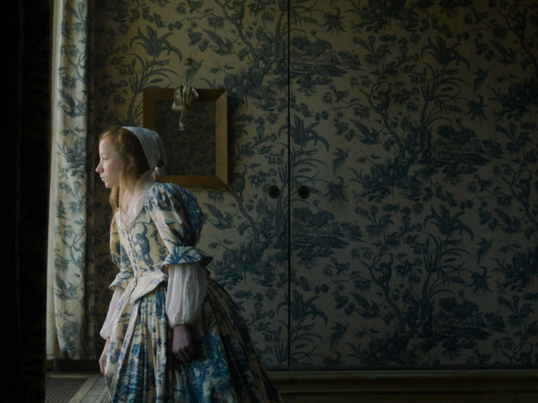
Installation, photography and moving image work by contemporary artists such as Mona Hatoum, Fiona Tan, Cornelia Parker and Martha Rosler reveal more complex ideas of enclosure and enchantment, alluding to the interior as a place that can be controlling, sinister and threatening as much as it can be a sanctuary.
The Enchanted Interior will include 84 oil paintings, watercolours, sculptures, films, installations, photography, prints and decorative art by 60 artists - almost half of which are women – including Dante Gabriel Rossetti, John Frederic Leighton, John William Waterhouse, J.A.M Whistler, Walter Crane, Max Ernst, Dorothea Tanning, Linder Sterling, Ursula Mayer, and Hayv Kahraman. Key lenders include Tate, V&A Museum, Royal Academy of Art, De Morgan Foundation, Guildhall Art Gallery, Russell-Cotes Art Gallery & Museum, and Leeds Art Gallery, as well as private collections and direct from artists.

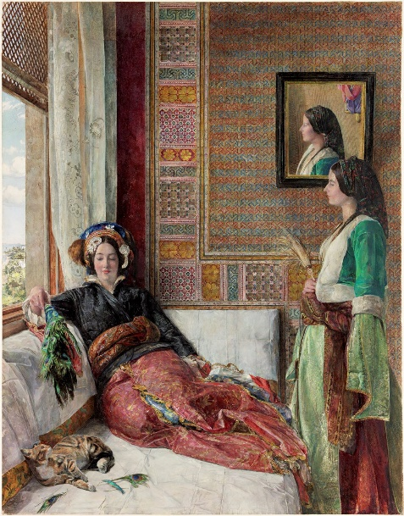
The loans are supported by the Weston Loan Programme with Art Fund. Created by the Garfield Weston Foundation and Art Fund, the Weston Loan Programme is the first ever UK-wide funding scheme to enable smaller and local authority museums to borrow works of art and artefacts from national collections.
The Enchanted Interior is built around three significant works in the Laing collection where women are trapped - psychologically or physically - in the environments we see them pictured in: Edward Burne-Jones’ Laus Veneris (1873-75) shows Venus in the claustrophobic chambers of her court; John Frederick Lewis’ Hhareem Life, Constantinople (1857) portrays two women in a harem, one gazing out of the window at the open spaces denied to her, and the other playing languidly with a domestic cat, a symbol for her own captivity; and a new acquisition, Nele/Nellie by Indonesian-born artist Fiona Tan (2013) shows the illegitimate daughter of Rembrandt Van Rijn pacing unhappily around a highly decorative house like the one she was confined to until her father’s death.
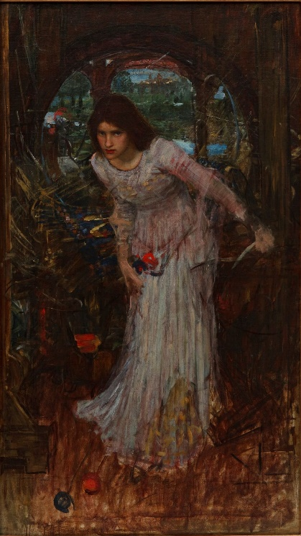
The exhibition examines the interior as a site in which women become ornamental objects, drawings on classical myths that feature imprisoned women and share compositional traits - the space is oppressive and lacking in depth, there is often a window (a view on to an inaccessible world) but never a door or an open path to reach it. Highlights will include Dante Gabriel Rossetti’s Marigolds (The Bower Maiden, Fleur-de-Marie) (1874, Nottingham City Museums), William Holman Hunt’s Past and Present (1868, Aberdeen Art Gallery & Museums), The Lady of Shalott (from the poem by Tennyson) by John William Waterhouse (c.1894 Falmouth Art Gallery), Emma Sandys’s Viola (c.1865–1877, Walker Art Gallery), A Moorish Girl with a Parakeet by Henriette Browne (1875, Russell-Cotes Art Gallery & Museum) and The Gilded Cage by Evelyn de Morgan (1900 – 1919, The De Morgan Foundation).
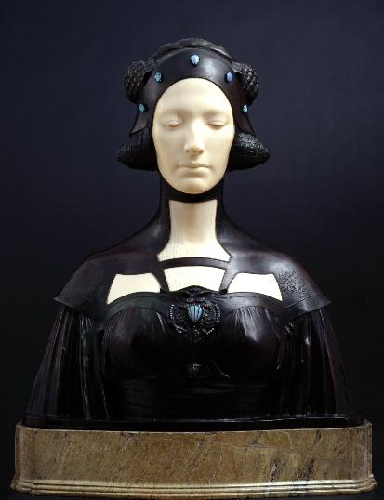
Another theme is the dual-edged tendency to depict real women as if they are objects, and to make objects in the image of women. A key loan is Pygmalion and Galatea by Ernest Normand (1881, Atkinson Art Gallery Collection) which depicts the Greek myth of the sculptor who fell in love with a statue he had carved out of ivory. Also included is a line engraving entitled The Chosen Five by J. Cother Web 1890, after the 1885 painting by Edwin Long (1885, Russell-Cotes Art Gallery & Museum) which showcases the Victorian fascination with the myth of the artist Zeuxis, who in his pursuit of the ideal model for his depiction of Helen of Troy, selects characteristics from five different female models. Sir George Frampton’s Lamia (1899-1900, Royal Academy) is not only a mythical femme fatale (from the Keats poem about a beautiful serpent-like creature who assumes female form to win the love of a mortal) but the polychrome materials and realist depiction of the sculpture also give the illusion that it is a real woman frozen in stone.
The Enchanted Interior will foreground works in which female artists resist the tropes of the gilded cage, or appropriate them for their own ends. A work that has been key to the creation of the whole exhibition is Mona Hatoum’s installation Home (1999, Tate). Hatoum appropriates objects related to the domestic kitchen, traditionally a feminine domain, and gives them a menacing, uncanny edge - potentially lethal electrical currents course through wires connected to items such as a colander, a whisk, a ladle and a heart-shaped pastry cutter.
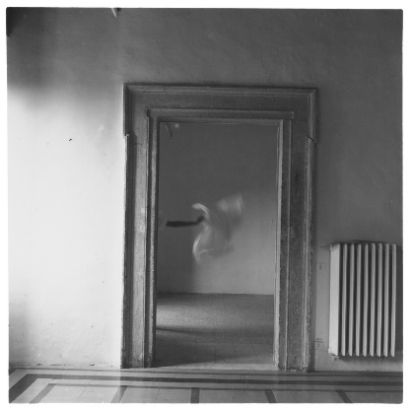
Exhibition curator Madeleine Kennedy says: “Although beautiful to behold, in many of these works, the interiors we see women inhabiting are governed by invisible but unbreakable rules, oppressive expectations, and in some cases, unseen tyrants. Through remarkable works by female artists, the allure of the enchanted interior is complicated, cutting through the outer illusion of opulence to the complex realities beneath, and offering alternatives ways of seeing the world and women’s place in it.”
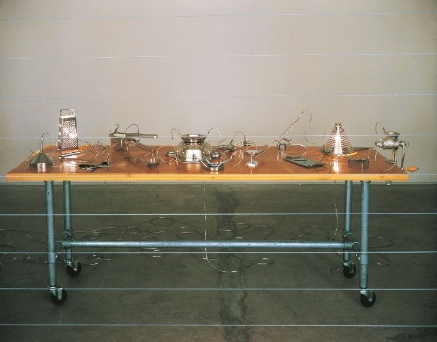
Julie Milne, Chief Curator of the Laing, Hatton and Shipley Art Galleries, says: “As is the case for many museums, some of the most beloved pieces in our collection are also among the most problematic, in this case harbouring thinly veiled expectations about women that we now recognise as detrimental. Rather than shy away from showing such works because of the prejudices they reflect, in ‘The Enchanted Interior’, our intention is to confront them with contemporary artists’ work that calls out their intoxicating effects, resulting in powerful dialogues between works that speak from radically different perspectives.”
Sophia Weston, Trustee of the Garfield Weston Foundation, said: “We are delighted that these incredibly beautiful works of art are coming to Tyne & Wear as part of our loan programme. When we started the Weston Loan Programme, we hoped it would help bring national treasures to many different communities across the UK and we are thrilled that the people of Newcastle will get to enjoy these masterpieces. We hope they will inspire the next generation of artists.”
The Enchanted Interior has been developed by the Laing Art Gallery and will tour nationally.
The exhibition was made possible by grants from the Weston Loan Programme with Art Fund, the John Ellerman Foundation, The Henry Moore Foundation, and a Jonathan Ruffer Curatorial Research Grant from Art Fund. It will be accompanied by an illustrated publication made possible by a grant from the Paul Mellon Centre for Studies in British Art. In kind support by Bon Bloemen.
To find out more visit www.laingartgallery.org.uk, follow us on Instagram and Twitter @LaingArtGallery and ‘Laing Art Gallery’ on Facebook.
NOTES TO EDITORS
All income generated from ticket sales support the Laing Art Gallery’s ambitious exhibition programme, help the gallery to inspire audiences through innovative learning activities and help keep the permanent collection free to all. The Laing Art Gallery is managed by Tyne & Wear Archives & Museums on behalf of Newcastle City Council and is home to an internationally important collection of art, focusing on British oil paintings, watercolours, ceramics, silver and glassware. The Gallery holds regularly changing exhibitions of historic, modern and contemporary art, and events including artist and curator talks and family activities. Recent achievements include becoming the first gallery to benefit from the Contemporary Art Society’s Great Works Scheme with an acquisition of a Glenn Brown work, and winning an award for Best Programme 2016 from Living North Magazines.

Garfield Weston Foundation - Established over 60 years ago in 1958, the Garfield Weston Foundation is a family-founded, grant-making charity which supports causes across the UK with grants around £70million annually. It has donated over £1billion to charities since it was established. One of the most respected charitable institutions in the UK, the Weston Family Trustees are descendants of the founder and they take a highly active and hands-on approach. The Foundation’s funding comes from an endowment of shares in the family business which includes Twinings, Primark, Kingsmill (all part of Associated British Foods Plc) and Fortnum & Mason, amongst others – a successful model that still endures today; as the businesses have grown so too have the charitable donations. From small community organisations to large national institutions, the Foundation supports a broad range of charities and activities that make a positive impact in the communities in which they work. More than 1,800 charities across the UK benefit each year from the Foundation’s grants.

Art Fund is the national fundraising charity for art. In the past five years alone Art Fund has given £34 million to help museums and galleries acquire works of art for their collections. It also helps museums share their collections with wider audiences by supporting a range of tours and exhibitions, and makes additional grants to support the training and professional development of curators. Art Fund is independently funded, with the core of its income provided by 139,000 members who receive the National Art Pass and enjoy free entry to over 240 museums, galleries and historic places across the UK, as well as 50% off entry to major exhibitions and subscription to Art Quarterly magazine. In addition to grant-giving, Art Fund’s support for museums includes Art Fund Museum of the Year (won by St Fagans National History Museum near Cardiff in 2019) and a range of digital platforms. Find out more about Art Fund and the National Art Pass at www.artfund.org

IMAGES
A selection of high-resolution images for media use can be downloaded here
Laus Veneris, 1873-1875 by Edward Burne Jones © Laing Art Gallery
Fiona Tan, Nele/Nellie 2013, courtesy the artist and Frith Street Gallery, London
Hhareem Life, Constantinople, 1857 by J.F. Lewis © Laing Art Gallery
The Lady of Shalott, JW Waterhouse © Falmouth Art Gallery Collection
Lamia, 1899-1900 by Sir George Frampton RA © Royal Academy of Arts, London; photographer: Paul Highnam
From Angel Series, 1977 by Francesca Woodman © Estate of Francesca Woodman/Charles Woodman / Artists Rights Society (ARS), New York and DACS, London 2019
Mona Hatoum, Home, 1999 © Mona Hatoum. Courtesy Alexander and Bonin, New York (Photo: Orcutt & Van Der Putten)

FOR MORE INFORMATION, INTERVIEWS & IMAGES
Please contact Tracy Jones at Brera PR – tracy@brera-london.com / 01702 216658 / 07887 514984 / www.brera-london.com

